ADDITIONAL COMMENTS CATEGORIES

Additional comments provided by local Ventnor residents on the back page of the 2015 Ventnor Our Place Survey provided further insight into the many concerns that local people have, not only short-term but also long-term.
Basic analysis and range of subjects expressed in the Additional Comments section of the Our Place Survey indicated that the comments fell into one or more of the following areas.
- Survey
- Ventnor
- Environment
- Local Tourism
- Media and Marketing
- Ventnor Town Council
- Public Toilets
- Car Parking
- Transport
- Dogs and Pigeons
- Upper Ventnor
- Ventnor Town
- Personal
- Retail Business
- People
- Property
- Volunteering
- Local Assets
- Mobile Coverage
- Local Landlords
- Service Problems
- Self-sufficiency

The information within the categories yield another picture or perspective of local concerns gained from the survey results that are expressed in the following diagram.
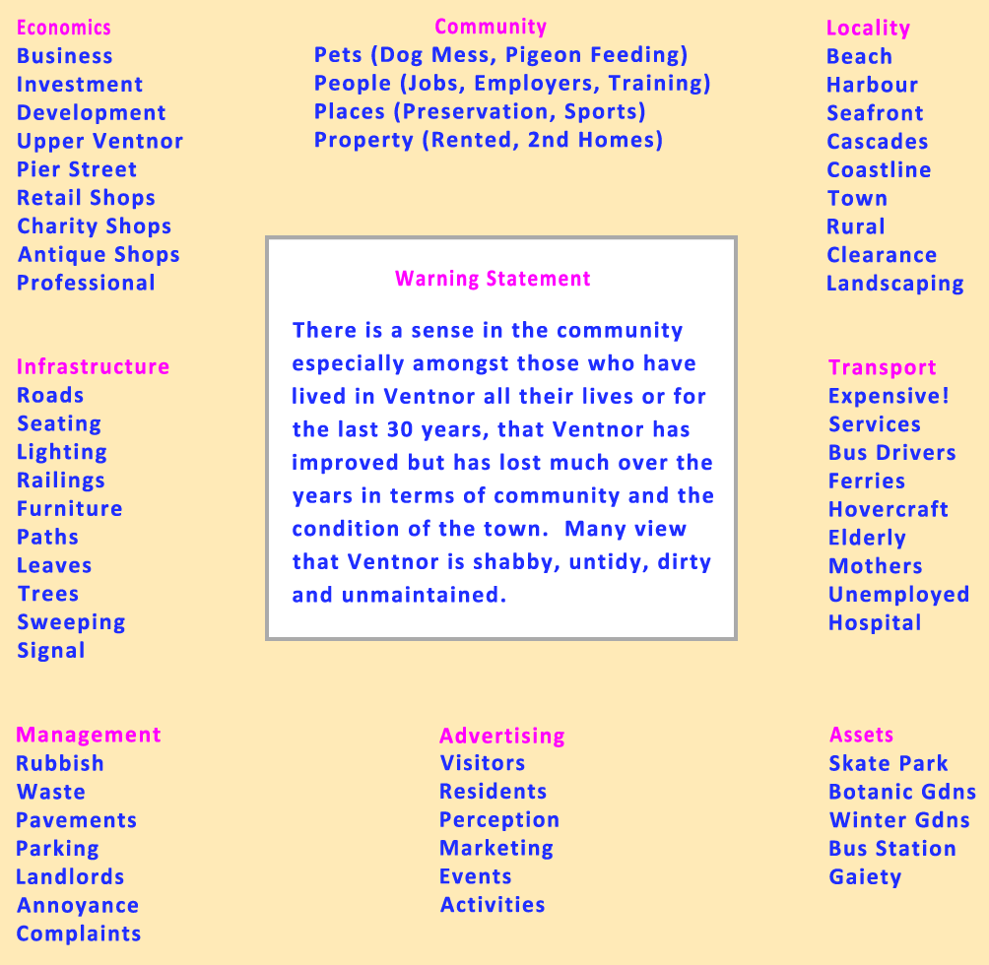
In effect, local people who provided additional comments about one or more concerns were basically focusing on the 8 plus 1 areas given in the above diagram. The plus 1 area is important because it is not only an internal perception, and experienced by many local people, but also shows their concern with respect to the potential perceptions of visitors and holidaymakers to the area. These people are genuinely concerned about the state and condition of Ventnor, and rightly so. Note that although only one person may have positively responded in a category in the following results, that one person has a network of relatives and friends that may also potentially share the same views and experiences. Positive is fine, but negative responses are not good for Ventnor, in whatever category, and therefore need to be carefully thought about and how best to turn those negative issues and problems around.
Our Place Survey 2015: Additional Comments from Ventnor Residents
Our Place survey responses (sorted by categories). | Written Concerns and Support by Ventnor Residents across Upper Ventnor, Ventnor Town, St Lawrence and Bonchurch. | Survey Results as of 30th of July 2015 (sorted according to response size – small to large).
 |  | Agree | Disagree
Survey | The Our Place survey content was relevant and useful | 3 | 4
 | The Our Place survey was poorly constructed | 3 | 0
 | Want the funding of the survey made public | 5 | 0
 | Money should have been spent on other things | 6 | 0
 |  | Agree | Disagree
Ventnor | Ventnor has community premises for groups | 0 | 1
 | Ventnor Esplanade needs improving | 1 | 0
 | Local job opportunities are poor in Ventnor | 1 | 0
 | Same volunteers doing everything for Ventnor | 1 | 0
 | Ventnor is a caring community | 2 | 0
 | Need to invest in beach safety | 2 | 0
 | Work with local employers for apprenticeships | 2 | 0
 | Necessary to maintain Blue Flag status | 3 | 0
 | Many interests and activities to do around Ventnor | 4 | 0
 | Ventnor has the most natural beauty | 4 | 0
 | Ventnor Esplanade and Beach is attractive | 4 | 1
 | Rural areas of Ventnor excellent | 4 | 0
 | Diverse local job market needed for local people | 4 | 0
 | Ventnor has a community feeling | 5 | 2
 | Ventnor beaches are Maintained | 6 | 2
 | Ventnor has a superb coastline for coastal walks | 8 | 0
 | Ventnor has improved over the years | 9 | 0
 | Ventnor needs to flourish and develop | 10 | 0
 | Ventnor is a friendly place | 14 | 0
 | There is no place like Ventnor | 22 | 0
 |  | Agree | Disagree
Environment | Ventnor is a clean and tidy place to live | 0 | 5
 | Ventnor road areas are regularly swept | 0 | 5
 | Trees and foliage are regularly managed | 0 | 2
 | Ventnor skate park is in good condition | 0 | 3
 | Local impressions of Ventnor are good | 0 | 1
 | Need to influence the Island Roads Works | 1 | 0
 | Railings and public seating need attentions | 1 | 0
 | Town pavements are dangerously narrow | 1 | 0
 | On-street parking in town is a problem | 1 | 0
 | Delivery and unloading problems in town | 1 | 0
 | Delivery bays need to be designated in town | 1 | 0
 | Footpaths and hedgerows are maintained | 1 | 4
 | Leaves from trees regularly cleared | 1 | 2
 | Public grass areas are regularly cut | 1 | 0
 | Local public gardens need planting and upkeep | 1 | 0
 | Emergency coastguard phone reinstalled | 1 | 0
 | Music too loud in Ventnor Park on Sunday | 1 | 0
 | Safe Haven should of been a visitors marina | 1 | 0
 | Harbour needs to be extended into a marina | 1 | 0
 | Beach ruined by poor design of the Haven | 1 | 0
 | There is local feeling of community pride | 1 | 2
 | Gaiety needs transforming for tourism | 1 | 0
 | Street lighting required in certain town areas | 1 | 0
 | Limit use of poisonous glyphoshate weed spraying | 1 | 0
 | Flower boxes needed on the Esplanade | 2 | 0
 | Spaces required for local allotments for growing | 2 | 0
 | Ventnor Park is excellently maintained | 3 | 0
 | More colourful planting around Cascades | 3 | 0
 | Hanging baskets needed around town | 4 | 0
 | Area looks good and welcoming for visitors | 5 | 0
 | Local roads are not in good condition | 6 | 0
 | Litter and waste is not regularly cleared | 7 | 0
 | Ventnor Town is dirty and shabby | 9 | 0
 |  | Agree | Disagree
Local Tourism | Visitor impressions of Ventnor is Good | 0 | 3
 | No problems with local tourism | 0 | 6
 | Ventnor seafront has a lot to offer visitors | 0 | 4
 | Local impression of tourism is good | 1 | 5
 | Mediocre tourism will not sustain Ventnor | 2 | 0
 | Visitors need to be encouraged to return | 3 | 0
 | Visitor are declining affecting local retail | 4 | 0
 | Put more effort into raising local tourism | 10 | 0
 |  | Agree | Disagree
Media and Marketing | Necessary to close Tourist Information | 0 | 4
 | Local attractions are adequately advertised | 0 | 8
 | Ventnor is properly marketed annually | 1 | 9
 | People with children stay and holiday elsewhere | 1 | 0
 | Need to advertise the niche local retail | 2 | 0
 | Local Chronicle reporting is excellent | 3 | 0
 | Tourist Information is vital to the area | 6 | 0
 |  | Agree | Disagree
Ventnor Town Council | It is necessary to cost cut the library | 0 | 8
 | It may be necessary to move Ventnor library | 0 | 3
 | Paying highest C.T band on Island is fair | 0 | 2
 | Police are dealing with local vandalism | 0 | 3
 | The work of the planning committee is useful | 0 | 4
 | Council is approachable and supporting | 2 | 1
 | Aim to have the Council precept increased | 1 | 0
 | Salisbury Gardens provides little return | 1 | 2
 | Continued problems with Undercliffe Drive | 1 | 0
 | Council should retain local public buildings | 1 | 0
 | Building should be sold to fund local projects | 1 | 0
 | The Ventnor Town Council website is poor | 1 | 0
 | Loss of public services is locally detrimental | 1 | 0
 | Precept not matching local responsibilities | 1 | 0
 | Industrial space is a problem in Ventnor | 1 | 0
 | Better traffic and attraction signage is needed | 1 | 0
 | Local authority to provide basic services | 1 | 0
 | Worry about the increase in C.T as pensioners | 1 | 0
 | Councillors appear not active in our community | 1 | 0
 | Self-reliance and sustainability important for Ventnor | 1 | 0
 | Pedestrianise the High Street and seafront | 1 | 0
 | Ventnor Council need to be more transparent | 2 | 0
 | The Green Room is good for the community | 2 | 0
 | Council managing well under present cuts | 3 | 0
 | Salisbury Gardens provides good offices | 3 | 0
 | Policing and protection is important | 3 | 0
 | Ventnor Town Council is incompetent | 4 | 1
 | The Flower's Brook campaign is important | 5 | 1
 | The library is valuable to the community | 10 | 0
 | Ventnor Town Council is doing a good job | 18 | 4
 |  | Agree | Disagree
Public Toilets | It was necessary to close some public toilets | 0 | 16
 | Public toilets need to be cleaned and not smell | 1 | 0
 | Public toilets are needed on Bonchurch beach | 1 | 0
 | Public toilets are necessary for mums and kids | 6 | 0
 | Public toilets expected by coach parties | 6 | 0
 | Public toilets are necessary for the disabled | 9 | 0
 | Public toilets are important for shoppers | 15 | 0
 | Public toilets are necessary for the Elderly | 17 | 0
 | Local public toilets are expected by visitors | 18 | 0
 | There is a severe lack of local public toilets | 22 | 0
 |  | Agree | Disagree
Car Parking | There are no local car parking problems | 0 | 11
 | Local households only need one parking permit | 0 | 1
 | Need carefully planned and policed on-street parking | 1 | 0
 | On-street parking difficult during holidays | 1 | 0
 | Permits for residential overnight car parking | 1 | 0
 | Esplanade ticket machines always broken | 1 | 0
 | Access to Wheelers Bay car park prevented | 1 | 0
 | Dudley Road car park is under used | 2 | 0
 | Esplanade needs more ticket machines | 2 | 0
 | Central car park is too expensive | 5 | 1
 | On-street parking for residents is a problem | 5 | 0
 | Tend to shop and park elsewhere out of Ventnor | 11 | 0
 | Local car parking tariffs are too expensive | 13 | 0
 | Ventnor needs low cost parking permits | 13 | 0
 | Afternoon free parking needed for shopping | 14 | 0
 | Local car parks need to be free sometimes | 16 | 0
 |  | Agree | Disagree
Transport | Local bus shelters are always clean | 0 | 2
 | High cost of ferry charges is not important | 0 | 4
 | The No. 6 needs to continue running | 1 | 0
 | Shuttle bus service is needed to visit attractions | 1 | 0
 | Bus service is poor to-and-from St Lawrence | 1 | 0
 | Limit the vehicle speed in the High Street | 1 | 0
 | New rail track from Shanklin to Ventnor needed | 1 | 0
 | Speed limits around Ventnor need to be lower | 1 | 0
 | Experience specific local area traffic congestion | 1 | 0
 | More speed cameras required in the area | 1 | 0
 | Community bus hours extended | 1 | 0
 | Introduce park & ride services from Dudley Road | 1 | 0
 | More car restrictions on the Esplanade | 1 | 0
 | More direct and cheaper route to St Mary's | 1 | 0
 | Bus driver attitudes can be off putting | 1 | 0
 | Ferry and hover charges need to be negotiated | 2 | 0
 | Areas of Ventnor poorly serviced and need car | 2 | 0
 | More safe cycle paths needed around Ventnor | 2 | 0
 | Local buses are important for non-car drivers | 3 | 0
 | Buses provide independence to the elderly | 3 | 0
 | Travelling on-and-off the Island is expensive | 3 | 0
 | Local buses are awkward and too expensive | 6 | 0
 |  | Agree | Disagree
Dogs and Pigeons | Dog owners clear up after their dogs foul | 0 | 14
 | There are adequate dog bins in the area | 0 | 2
 | Residents should be allowed to feed pigeons | 0 | 3
 | Dogs restricted on beach during summer | 2 | 0
 | Ventnor has a problem with pigeons | 2 | 0
 | Pigeons seed attracts rats and vermin | 2 | 0
 | Dogs should be kept on leads in Ventnor Park | 3 | 0
 | Introduction of more dog wardens | 3 | 0
 | Pigeon mess affects the condition of the town | 3 | 0
 | Pigeons damage property and are a health risk | 3 | 0
 | Dog mess on streets and grass is a health hazard | 4 | 0
 | Dog mess not cleared in Ventnor Park and Town | 5 | 0
 | Dog owners should be fined if mess not cleared | 12 | 0
 |  | Agree | Disagree
Upper Ventnor | Businesses are not encourage to relocate here | 1 | 0
 | There is no public car park in Upper Ventnor | 1 | 0
 | Lacks a range of good shopping for families | 2 | 0
 |  | Agree | Disagree
Ventnor Town | Need to prevent shops from cluttering streets | 0 | 0
 | Ventnor town appears to be in good condition | 0 | 6
 | Turn local waste land into local car parks | 1 | 0
 | Bus station needs to be used or new frontage | 2 | 0
 | Some local buildings and land need clearance | 3 | 0
 | Pier Street needs improving and looks shabby | 4 | 0
 | Derelict land areas in Ventnor need restoration | 4 | 0
 | Restore or demolish derelict Esplanade buildings | 4 | 0
 | Shop owners should repaint their frontages | 5 | 0
 |  | Agree | Disagree
Personal | It is easy to move about home | 0 | 2
 | Getting out is relatively easy | 0 | 5
 | I have a mental Condition | 1 | 0
 | The beach is inaccessible to most elderly | 2 | 0
 | Esplanade access is difficult for the elderly | 2 | 0
 | I have a disability or impairment | 6 | 0
 | I have to use mental health services | 7 | 0
 |  | Agree | Disagree
Retail Business | Private sector needs to help the local community | 0 | 1
 | There is a lack of business opportunity | 1 | 0
 | The business rates need to be lower | 1 | 0
 | Local business-community partnerships | 1 | 0
 | Incentives for business relocation to Ventnor | 1 | 0
 | There are too many estate agents | 1 | 0
 | Need to attract high-tech business to Ventnor | 1 | 0
 | Promote attractiveness of internet businesses | 1 | 0
 | Ground floor seafront premises should be retail | 1 | 0
 | Ventnor seafront properties need attention | 1 | 0
 | Empty businesses on Esplanade need attention | 1 | 0
 | Business start-ups will not raise Ventnor economy | 1 | 0
 | Ventnor needs to become a destination for shopping | 1 | 0
 | Ventnor needs to attract new businesses | 2 | 0
 | Ventnor needs to secure new investment | 3 | 0
 | There are too many cafés and charity shops | 4 | 0
 |  | Agree | Disagree
People | Youngsters need more direction | 1 | 0
 | Youth must be more accountable | 1 | 0
 | Important to support local sports clubs | 1 | 0
 | Focus should be on younger people | 1 | 0
 | Too much alcohol consumed by local youth | 1 | 0
 | There is a lack of youth activities | 1 | 0
 | Important to develop local arts culture | 2 | 0
 | Need for craft units for local young artists | 2 | 0
 | There are too many drug opportunities | 2 | 0
 | Young people and children need engagement | 2 | 0
 | More fun activities needed for youngsters | 2 | 0
 | There is a lack of sports space for young people | 2 | 0
 | There is a lack of things to do for young children | 2 | 0
 | There are no safe facilities for toddlers and children | 2 | 0
 | Local youth have not responsibility for Ventnor | 3 | 0
 | Local youth are not concerned about accountability | 4 | 0
 |  | Agree | Disagree
Property | Rubbish from second homes not cleared for days | 1 | 0
 | Second homes ramp local property market | 1 | 0
 | Young unable to afford Ventnor properties | 1 | 0
 | There is a shortage of 3-bed home in the area | 1 | 0
 | Second home need to be audited | 2 | 0
 | Second home owners should pay more C.T | 2 | 0
 | Second home owners are willing to get locally involved | 2 | 0
 | Keep holiday homes to the minimum | 2 | 0
 | Seafront flats are often empty and over priced | 2 | 0
 |  | Agree | Disagree
Volunteering | I am restricted by disability to volunteer | 3 | 0
 | I am restricted by age to volunteer | 5 | 0
 |  | Agree | Disagree
Local Assets | Botanical Gardens entrance fee is reasonable | 0 | 3
 | Botanical Gardens are beneficial to the community | 3 | 2
 | Botanical Gardens have become too expensive to visit | 2 | 0
 | Need Winter Gardens back under community control | 11 | 0
 |  | Agree | Disagree
Mobile Coverage | I always get a signal with my provider | 0 | 2
 | Phone coverage across Ventnor is good | 0 | 2
 | My television reception is often poor | 1 | 0
 |  | Agree | Disagree
Local Landlords | Landlords look after their leased properties | 0 | 3
 | Local landlords do not care about their tenants | 1 | 0
 | Local landlords have no accountability | 2 | 0
 | Landlords forced to improve dwellings | 3 | 0
 |  | Agree | Disagree
Service Problems | Bring back local podiatry and chiropody services | 1 | 0
 | W.B boat bay increases annually but no facilities | 1 | 0
 | Japanese weed spreading around Monks Bay | 1 | 0
 | Support living at home services needed | 1 | 0
 | Need to manage and maintain housing locally | 1 | 0
 |  | Agree | Disagree
Self-Sufficiency | Need to develop reliance on locally grown produce | 1 | 0
 | Need to collect and purify local water | 1 | 0
 | Need to produce locally supplied energy | 1 | 0

